ANNEX I
Definitions applicable for the annexes
The following definitions shall apply:
- ‘alternative text’ means text provided as an alternative to a graphic allowing information to be presented in non-graphical form where display devices cannot render the graphic or as an aid to accessibility such as input to voice synthesis applications
- ‘commercial dishwasher’ means a machine which cleans, rinses, and optionally dries wash ware, such as dishware, glassware, cutlery, and other utensils connected to the preparation, cooking, arrangement or serving of food (including drinks), using chemical, mechanical, and thermal means; which is connected to electric mains and which is designed to be used principally for commercial (non-household, non-industrial) purposes as stated by the manufacturer in the Declaration of Conformity (DoC);
- ‘cycle’ means a complete cleaning, rinsing, and drying process, as defined by the programme selected, consisting of a series of operations until all activity ceases;
- ‘display mechanism’ means any screen, including tactile screen, or other visual technology used for displaying internet content to users;
- ‘Energy Efficiency Index’ (EEI) means the ratio of the standard programme energy consumption to the reference energy consumption;
- ‘guarantee’ means any undertaking by the retailer or supplier to the consumer to:
      - reimburse the price paid; or
      - replace, repair or handle the commercial dishwashers in any way if they do not meet the specifications set out in the guarantee statement or in the relevant advertising;
- ‘hood-type dishwasher’ means a manually loaded, programmable, hood-type, pass-through machine with typically one detergent-circulating zone and a fresh-water rinsing process;
- ʻmains’ or ‘electric mains’ means the electricity supply from the grid of 230 (±10 %) volts of alternating current at 50 Hz;
- ‘nested display’ means any visual interface where an image or data set is accessed by a mouse click, mouse roll-over or tactile screen expansion of another image or data set;
- ‘programme’ means a series of operations that are pre-defined and are declared by the supplier as suitable for specified levels of soil or types of load, or both;
- ‘programme duration’ means the length of time beginning with the initiation of the programme selected, excluding any user programmed delay, until the end of the programme is indicated and the user has access to the load;
- ‘quick response’ (QR) code means a matrix barcode included on the energy label of a product model that links to that model’s information in the public part of the product database;
- ‘rated capacity’ means the maximum number of plates, which can be cleaned, rinsed and dried in a commercial dishwasher in one cycle when loaded in accordance with the supplier’s instructions;
- ‘resoiling performance’ means the performance of the commercial dishwasher regarding the soiling of the washware (e.g. on the rear side of the washware) by the cleaning process, which causes a deterioration of the cleaning result;
- ‘standard programme’ means the name of the programme of a commercial dishwasher declared by the manufacturer, importer or authorised representative as suitable to clean normally soiled washware, and to which the ecodesign requirements on energy and water efficiency, cleaning, resoiling and hygiene performance relate;
- ‘standard programme energy consumption’ (SPEC) means the energy consumption of a commercial dishwasher for standard programme, expressed in kilowatt hour per plate;
- ‘standard programme water consumption’ (SPWC) means the water consumption of a commercial dishwasher for the standard programme, expressed in litres per plate
- ‘tactile screen’ means a screen responding to touch, such as that of a tablet computer, slate computer or a smartphone;
- ‘under-counter one-tank dishwasher’ means a manually loaded, programmable, undercounter front loader with typically one detergent circulating zone and a fresh-water rinsing process.

ANNEX II
A. Energy efficiency classes
The energy efficiency class of an under-counter one-tank dishwasher shall be determined on the basis of its Energy Efficiency Index (EEI) as set out in Table 1.
The EEI of an under-counter one-tank dishwasher shall be calculated in accordance with Annex IV.
Table 1
Energy efficiency classes of under-counter one-tank dishwashers
Energy efficiency class | Energy Efficiency Index
A | EEI ≤ 100
B | 100 < EEI ≤ 110
C | 110 < EEI ≤ 120
D | 120 < EEI ≤ 130
E | 130 < EEI ≤ 140
F | 140 < EEI ≤ 150
G | 150 < EEI

The energy efficiency class of a hood-type dishwasher shall be determined on the basis of its Energy Efficiency Index (EEI) as set out in Table 2.
The EEI of a hood-type dishwasher shall be calculated in accordance with Annex IV.
Table 2
Energy efficiency classes of hood-type dishwashers
Energy efficiency class | Energy Efficiency Index
A | EEI ≤ 100
B | 100 < EEI ≤ 106
C | 106 < EEI ≤ 112
D | 112 < EEI ≤ 118
E | 118 < EEI ≤ 124
F | 124 < EEI ≤ 130
G | 130 < EEI

ANNEX III
Label
- LABEL
(currently only a template, will be adapted according to the information aspects specified below)
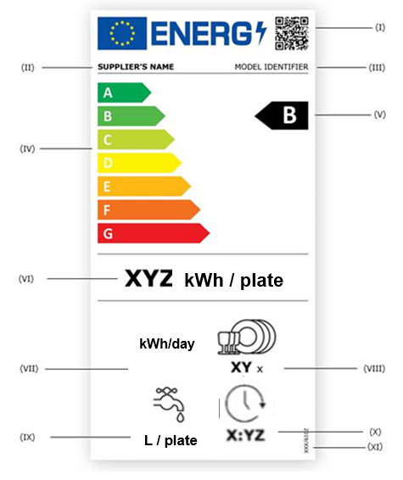
The following information shall be included in the label:
I. QR code;
II. supplier’s name or trade mark;
III. supplier’s model identifier;
IV. scale of energy efficiency classes from A to G;
V. the energy efficiency class determined in accordance with point A of Annex II;
VI. standard programme energy consumption (SPEC) in kWh per plate, rounded to three decimal places;
VII. daily energy consumption for the standard programme in kWh, rounded to one decimal place;
VIII. rated capacity in plates, for the standard programme;
IX. standard programme water consumption (SPWC) in litres per plate, rounded to three decimal places;
X programme duration of the standard programme (T_{SPR}) in seconds;

XI. the number of this Regulation, that is ‘XXXX/XXX’ [PO- please insert the number of this Regulation in this point and in the right bottom corner of the label].

- LABEL DESIGN
The design of the label shall be as in the figure below (currently only a template, will be adapted according to the information aspects specified above and the design aspects defined below).
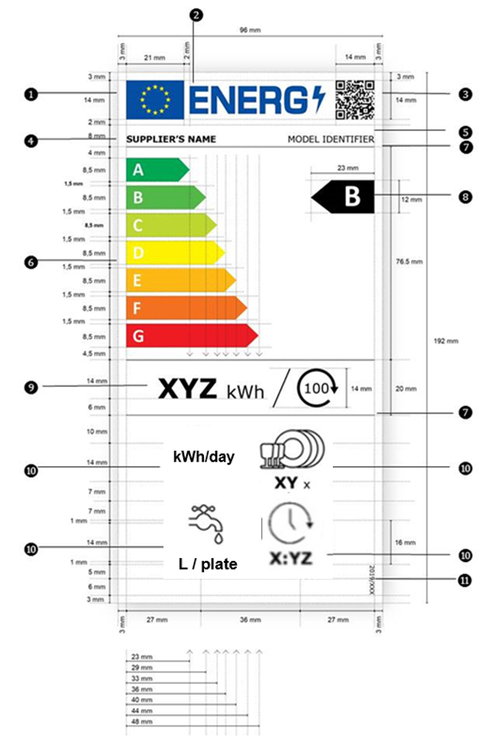

Whereby:
      - the label shall be at least 96 mm wide and 192 mm high. Where the label is printed in a larger format, its content shall nevertheless remain proportionate to the specifications above;
      - the background of the label shall be 100 % white;
      - the typefaces shall be Verdana and Calibri;
      - the dimensions and specifications of the elements constituting the label shall be as indicated in the label design for commercial dishwashers;
      - colours shall be CMYK – cyan, magenta, yellow and black, following this example: 0,70,100,0: 0 % cyan, 70 % magenta, 100 % yellow, 0 % black;
      - the label shall fulfil all the following requirements (numbers refer to the figure above):
 the colours of the EU logo shall be as follows:
- the background: 100,80,0,0;
- the stars: 0,0,100,0;
 the colour of the energy logo shall be: 100,80,0,0;
 the QR code shall be 100 % black;
 the supplier’s name shall be 100 % black and in Verdana Bold, 9 pt;
 the model identifier shall be 100 % black and in Verdana Regular 9 pt;
 the A to G scale shall be as follows:
- the letters of the energy efficiency scale shall be 100 % white and in Calibri Bold 19 pt; the letters shall be centred on an axis at 4,5 mm from the left side of the arrows;
- the colours of the A to G scale arrows shall be as follows:
- A-class: 100,0,100,0;
- B-class: 70,0,100,0;
- C-class: 30,0,100,0;
- D-class: 0,0,100,0;
- E-class: 0,30,100,0;
- F-class: 0,70,100,0;
- G-class: 0,100,100,0;
 the internal dividers shall have a weight of 0,5 pt and the colour shall be 100 % black;
 the colour of the letter of the energy efficiency class shall be 100 % white and in Calibri Bold 33 pt. The energy efficiency class arrow and the corresponding arrow in the A to G scale shall be positioned in such a way that their tips are aligned. The letter in the energy efficiency class arrow shall be positioned in the centre of the rectangular part of the arrow which shall be 100 % black;
 the value of the standard programme energy consumption per plate shall be in Verdana Bold 28 pt; ‘kWh / plate’ shall be in Verdana Regular 18 pt;
 the pictograms shall be as shown as in the label designs and as follows:
- the pictograms' lines shall have a weight of 1,2 pt and they and the texts (numbers and units) shall be 100 % black;
- the texts under the pictograms shall be in Verdana Bold 16 pt with the unit in Verdana Regular 12 pt, and they shall be centred under the pictograms;
- the airborne acoustical noise emission pictogram: to be deleted;
 the number of the regulation shall be 100 % black and in Verdana Regular 6 pt.

ANNEX IV
Measurement methods and calculations
For the purposes of compliance and verification of compliance with the requirements of this Regulation, measurements and calculations shall be made using harmonised standards the reference numbers of which have been published for this purpose in the Official Journal of the European Union, or other reliable, accurate and reproducible methods, which takes into account the generally recognised state-of-the-art, and in line with the following provisions.
The energy efficiency index, daily energy consumption, energy consumption, water consumption, and programme duration of a commercial dishwasher model shall be measured and/or calculated using the standard programme with the commercial dishwasher loaded at rated capacity.

- ENERGY EFFICIENCY INDEX
For the calculation of the Energy Efficiency Index (EEI) of a commercial dishwasher model, the standard programme energy consumption (SPEC) of the commercial dishwasher is compared to its reference energy consumption (REC).
The EEI is calculated as follows and rounded to one decimal place:
$$EEI=\frac{SPEC}{REC}·100$$
Where:
SPEC is the standard programme energy consumption of the commercial dishwasher, measured in kWh/plate and rounded to three decimal places;
REC is the reference energy consumption of the commercial dishwasher in kWh/plate specified as follows:
(1) for under-counter one-tank dishwashers:
REC = [0.0130 kWh/plate];
(2) for hood-type dishwashers:
REC = [0.0167 kWh/plate].
- DAILY ENERGY CONSUMPTION
The daily energy consumption of dishwashers (DEC) is calculated as follows and rounded to one decimal place:
$$DEC=E_{S}·2+SPEC·n_{P}·n_{R}+P_{U}·9h$$
Where:
E_{S} is the energy consumption for initial fill in kWh;
SPEC is the standard programme energy consumption in kWh/plate;
n_{P} is the number of plates per rack;
n_{R} is the number of racks per day, with:
(1) 55 racks per day for under-counter one-tank dishwashers;
(2) 110 racks per day for hood-type dishwashers;
P_{U} is the power of the ready-to-use mode in kW.

3. ENERGY CONSUMPTION
The standard programme energy consumption (SPEC) is calculated as follows and rounded to three decimal places:
$$SPEC=\frac{E_{C}}{p_{R}}$$
where:
E_{C} is the standard programme energy consumption of the commercial dishwasher measured in kWh/cycle and rounded to three decimal places;
p_{R} is the number of plates per rack of the commercial dishwasher in the standard programme.

4. WATER CONSUMPTION
The standard programme water consumption (SPWC) is calculated as follows and rounded to three decimal places:
$$SPWC=\frac{V_{C}}{p_{R}}$$
where:
V_{C} is the standard programme water consumption of the commercial dishwasher measured in l/cycle and rounded to one decimal place;
p_{R} is the number of plates per rack of the commercial dishwasher in the standard programme.

5. PROGRAMME DURATION
The programme duration for the standard programme (T_{SPR}) is measured from the initiation of the programme (excluding any user-programmed delay) until an end of programme indicator is showing the end of the programme. T_{SPR} is expressed in seconds.

ANNEX V
Product information sheet
The information part of the product information sheet of commercial dishwashers pursuant to point 1(b) of Article 3 shall be entered into the product database by the supplier according to Table 3.
The user manual or other literature provided with the product shall clearly indicate the link to the model in the product database as a human-readable Uniform Resource Locator (URL) or as QR-code or by providing the product registration number.
Table 3
Content, order and format of the product information sheet
Supplier’s name or trade mark:
Supplier’s address^{b}:
Model identifier:
Type of commercial dishwasher:
 | Parameter | Value | Parameter | Value
 | Under-counter one-tank dishwasher | [Yes/No] | Hood-type dishwasher | [Yes/No]
Design options implemented:
 | Parameter | Value | Parameter | Value
 | Exhaust heat recovery (regenerator) | [Yes/No] | Exhaust air heat pump | [Yes/No]
 | Automatic programme for load and soil recognition | [Yes/No] | Improved thermal insulation (double-walled design) | [Yes/No]
 | Further substitution of metals by polymers | [Yes/No] | Modular design and reuse of electronics | [Yes/No]
 | Energy recovery from drain water | [Yes/No] | Other (please specify): | [Yes/No]
General parameters:
Parameter |  | Value | Parameter | Value
Rated capacityª (number of plates) |  | X | Rack size  (plates / rack) | X
Performance of the standard programme:
Parameter |  | Value | Parameter | Value
EEIª |  | X,X | Energy efficiency classª | [A/B/C/D/E/F/G]^{c}
Daily energy consumption in kWh |  | X,X | Power of ready-to-use mode in kW | X,X
Energy consumption for initial fill in kWh |  | X,X | Water consumption for initial fill in l | X,X
Cleaning performance (x_{clean}) in % |  | X | Resoiling performance (x_{res}) | X,X
Number of bioindicators with a minimum reduction of 5-log level (in the cutlery tray) |  | X | Number of bioindicators with a minimum reduction of 4-log level (in the cutlery tray) | X
Share of bioindicators with a minimum reduction of 5-log level (on test plates) |  | X | Number of bioindicators with a minimum reduction of 4-log level (on test plates) | X
Number of bioindicators with a minimum reduction of 5-log level (in the test rack) |  | X
Energy consumption in kWh [per cycle], based on the standard programme. Actual energy consumption will depend on how the appliance is used. |  | X,XXX | Water consumption in litres [per cycle], based on the standard programme. Actual water consumption will depend on how the appliance is used and on the hardness of the water. | X,X
Standard programme energy consumption per plate (SPEC) in kWh |  | X,XXX | Standard programme water consumption per plate (SPWC) in l | X,XXX
Programme timeª (T_{SPR}) in s |  | X
Minimum duration of the guarantee offered by the supplier^{b}:
Additional information:
Weblink to the supplier’s website, where the information in point 6 of Annex II to Commission Regulation (EU) XXXX/XXX [OP – please insert the Regulation number of the accompanying Ecodesign Regulation]^{b} is found:
ª for the standard programme.
^{b} changes to these items shall not be considered relevant for the purposes of paragraph 4 of Article 4 of Regulation (EU) 2017/1369.
^{c} if the product database automatically generates the definitive content of this cell the supplier shall not enter these data.

ANNEX VI
Technical documentation
- The technical documentation referred to in point 1(d) of Article 3 shall include:
      - information as set out in Annex V;
      - information as set out in Table 4; these values are considered as the declared values for the purpose of the verification procedure in Annex IX;
Table 4
Information to be included in the technical documentation
PARAMETER | UNIT | VALUE
Standard programme energy consumption (SPEC) rounded to three decimal places | kWh/plate | X,XXX
Energy Efficiency Index (EEI) | - | X,X
Daily energy consumption of the standard programme rounded to one decimal place | kWh | X,X
Standard programme water consumption (SPWC) rounded to three decimal places | l/plate | X,XXX
Duration of the standard programme (T_{SPR}) | s | X
      - where appropriate, the references of the harmonised standards applied;
      - where appropriate, the other technical standards and specifications used;
      - the details and the results of calculations performed in accordance with Annex IV;
      - a list of all equivalent models including the model identifier.
- Where the information included in the technical documentation for a particular commercial dishwasher model has been obtained by any of the following methods, or both:
- from a model that has the same technical characteristics relevant for the technical information to be provided but is produced by a different supplier;
- by calculation on the basis of design or extrapolation from another model of the same or a different supplier,
the technical documentation shall include the details of such calculation, the assessment undertaken by suppliers to verify the accuracy of the calculation and, where appropriate, the declaration of identity between the models of different suppliers.

ANNEX VII
Information to be provided in visual advertisements, in technical promotional material in distance selling and in telemarketing, except distance selling on the Internet
- In visual advertisements, for the purposes of ensuring conformity with the requirements laid down in point 1(e) of Article 3 and point (c) of Article 4, the energy efficiency class and the range of energy efficiency classes available on the label shall be shown as set out in point 4 of this annex.
- In technical promotional material, for the purposes of ensuring conformity with the requirements laid down in point 1(f) of Article 3 and point (d) of Article 4, the energy efficiency class and the range of energy efficiency classes available on the label shall be shown as set out in point 4 of this annex.
- Any paper-based distance selling must show the energy efficiency class and the range of energy efficiency classes available on the label as set out in point 4 of this annex.
- The energy efficiency class and the range of energy efficiency classes shall be shown, as indicated in Figure 1, with:
      - an arrow, containing the letter of the energy efficiency class in 100 % white, Calibri Bold, and in a font size at least equivalent to that of the price, when the price is shown;
      - the colour of the arrow matching the colour of the energy efficiency class;
      - the range of available efficiency classes in 100 % black; and,
      - the size shall be such that the arrow is clearly visible and legible. The letter in the energy efficiency class arrow shall be positioned in the centre of the rectangular part of the arrow, with a border of 0,5 pt in 100 % black placed around the arrow and the letter of the energy efficiency class.
By way of derogation, if the visual advertisement, technical promotional material or paper-based distance selling is printed in monochrome, the arrow can be in monochrome in that visual advertisement, technical promotional material or paper-based distance selling.

Figure 1: Coloured/monochrome left/right arrow, with range of energy efficiency classes indicated
- Telemarketing-based distance selling must specifically inform the customer of the energy efficiency class of the product and of the range of energy efficiency classes available on the label, and that the customer can access the label and the product information sheet through the product database website, or by requesting a printed copy.
- For all the situations mentioned in points 1 to 3 and 5, it must be possible for the customer to obtain, on request, a printed copy of the label and the product information sheet.

ANNEX VIII
Information to be provided in the case of distance selling through the internet
- The electronic label made available by suppliers in accordance with point 1(g) of Article 3 shall be shown on the display mechanism in proximity to the price of the product. The size shall be such that the label is clearly visible and legible and shall be proportionate to the size specified in point 2 of Annex III. The label may be displayed using a nested display, in which case the image used for accessing the label shall comply with the specifications laid down in point 2 of this Annex. If nested display is applied, the label shall appear on the first mouse click, mouse roll-over or tactile screen expansion on the image.
- The image used for accessing the label in the case of nested display, as indicated in Figure 2, shall:
      - be an arrow in the colour corresponding to the energy efficiency class of the product on the label;
      - indicate the energy efficiency class of the product on the arrow in 100 % white, Calibri Bold and in a font size equivalent to that of the price;
      - have the range of available efficiency classes in 100 % black; and,
      - have one of the following two formats, and its size shall be such that the arrow is clearly visible and legible. The letter in the energy efficiency class arrow shall be positioned in the centre of the rectangular part of the arrow, with a visible border in 100 % black placed around the arrow and the letter of the energy efficiency class:

Figure 2: Coloured left/right arrow, with range of energy efficiency classes indicated
- In the case of nested display, the sequence of display of the label shall be as follows:
      - the image referred to in point 2 of this Annex shall be shown on the display mechanism in proximity to the price of the product;
      - the image shall link to the label set out in Annex III;
      - the label shall be displayed after a mouse click, mouse roll-over or tactile screen expansion on the image;
      - the label shall be displayed by pop up, new tab, new page or inset screen display;
      - for magnification of the label on tactile screens, the device conventions for tactile magnification shall apply;
      - the label shall cease to be displayed by means of a close option or other standard closing mechanism;
      - the alternative text for the graphic, to be displayed on failure to display the label, shall be the energy efficiency class of the product in a font size equivalent to that of the price.
- The electronic product information sheet made available by suppliers in accordance with point 1(h) of Article 3 shall be shown on the display mechanism in proximity to the price of the product. The size shall be such that the product information sheet is clearly visible and legible. The product information sheet may be displayed using a nested display or by referring to the product database, in which case the link used for accessing the product information sheet shall clearly and legibly indicate ‘Product information sheet’. If a nested display is used, the product information sheet shall appear on the first mouse click, mouse roll-over or tactile screen expansion on the link.

ANNEX IX
Verification procedure for market surveillance purposes
The verification tolerances set out in this Annex relate only to the verification of the measured parameters by Member State authorities and shall not be used by the supplier as an allowed tolerance to establish the values in the technical documentation. The values and classes on the label or in the product information sheet shall not be more favourable for the supplier than the values reported in the technical documentation.
Where a model has been designed to be able to detect it is being tested (e.g. by recognising the test conditions or test cycle), and to react specifically by automatically altering its performance during the test with the objective of reaching a more favourable level for any of the parameters specified in this Regulation or included in the technical documentation or included in any of the documentation provided, the model and all equivalent models shall be considered not compliant.
When verifying the compliance of a product model with the requirements laid down in this Regulation, the authorities of the Member States shall apply the following procedure:
- The Member State authorities shall verify one single unit of the model.
- The model shall be considered to comply with the applicable requirements if:
      - the values given in the technical documentation pursuant to point 3 of Article 3 of Regulation (EU) 2017/1369 (declared values), and, where applicable, the values used to calculate these values, are not more favourable for the supplier than the corresponding values given in the test reports; and
      - the values published on the label and in the product information sheet are not more favourable for the supplier than the declared values, and the indicated energy efficiency class are not more favourable for the supplier than the class determined by the declared values; and
      - when the Member State authorities test the unit of the model, the determined values (the values of the relevant parameters as measured in testing and the values calculated from these measurements) comply with the respective verification tolerances as given in Table 4.
- If the results referred to in points 2(a) or (b) are not achieved, the model and all equivalent models shall be considered not to comply with this Regulation.
- If the result referred to in point 2(c) is not achieved, the Member State authorities shall select three additional units of the same model for testing. As an alternative, the three additional units selected may be of one or more equivalent models.
- The model shall be considered to comply with the applicable requirements if for these three units the arithmetical mean of the determined values complies with the respective tolerances given in Table 4.
- If the result referred to in point 5 is not achieved, the model and all equivalent models shall be considered not to comply with this Regulation.
- The Member State authorities shall provide all relevant information to the authorities of the other Member States and to the Commission without delay after a decision being taken on the non-compliance of the model according to points 3 and 6.
The Member State authorities shall use the measurement and calculation methods set out in Annex IV.
The Member State authorities shall only apply the verification tolerances that are set out in Table 4 and shall only use the procedure described in points 1 to 7 for the requirements referred to in this Annex. For the parameters in Table 5, no other tolerances, such as those set out in harmonised standards or in any other measurement method, shall be applied.
Table 5- Verification tolerances
Parameter | Verification tolerances
Energy consumption for initial fill | The determined value* shall not exceed the declared value by more than 10 %.
Water consumption for initial fill | The determined value* shall not exceed the declared value by more than 10 %.
Power of ready-to-use mode | The determined value* shall not exceed the declared value by more than 10 %.
Rated capacity (number of plates) | The determined value* shall not exceed the declared value by more than 10%.
Cleaning performance (x_{clean}) | The determined value* shall not be less than the declared value of x_{clean} by more than 10 %.
Energy consumption per cycle | The determined value* shall not exceed the declared value by more than 10 %.
Water consumption per cycle | The determined value* shall not exceed the declared value by more than 10 %.
Standard programme energy consumption per plate (SPEC) | The determined value* shall not exceed the declared value of SPEC by more than 10 %.
Standard programme water consumption per plate (SPWC) | The determined value* shall not exceed the declared value of SPWC by more than 10 %.
Programme duration (T_{SPR}) | The determined value* shall not exceed the declared value of T_{SPR} by more than 5 % or 6 seconds, whichever is the longer.
* In the case of three additional units tested as prescribed in point 4, the determined value means the arithmetical mean of the values determined for these three additional units.

Commission Regulation (EU) 2019/XXX [OP please enter the number of the Ecodesign Regulation for commercial dishwashers] of [OP please enter the date of adoption of this Regulation] laying down ecodesign requirements for commercial dishwashers pursuant to Directive 2009/125/EC of the European Parliament and of the Council amending Commission Regulation (EC) No 1275/2008.

